Adeline Company description：

**Main page description:**

Night falls, the evening lights are lit. After a long day of work, why not relax and enjoy a beautiful piece of music at your own pace? Sip a delicious selected coffee from one of our fine bone china cups, or experience an organic green tea from Fuji mountain brewed to perfection in our craft sandstone ceramic pots.   
Adeline provides you with superior service and exceptional quality.

**Narumi page**: pictures with descriptions (will send you the link with Narumi’s pictures and product descriptions)

**Ceramics**: Integrates stability & elegance of traditional wares with modernity

Artistic mood/professional accomplishments/practical considerations A cup of good tea-refreshing with our sandstone ceramics teapot will extend your well-being. (Waiting for Lin’s ceramics studio to send pictures and products’ descriptions) –Don't use their name or products pics yet

**Coffee page**: (Waiting to have other countries’ package pictures designed)

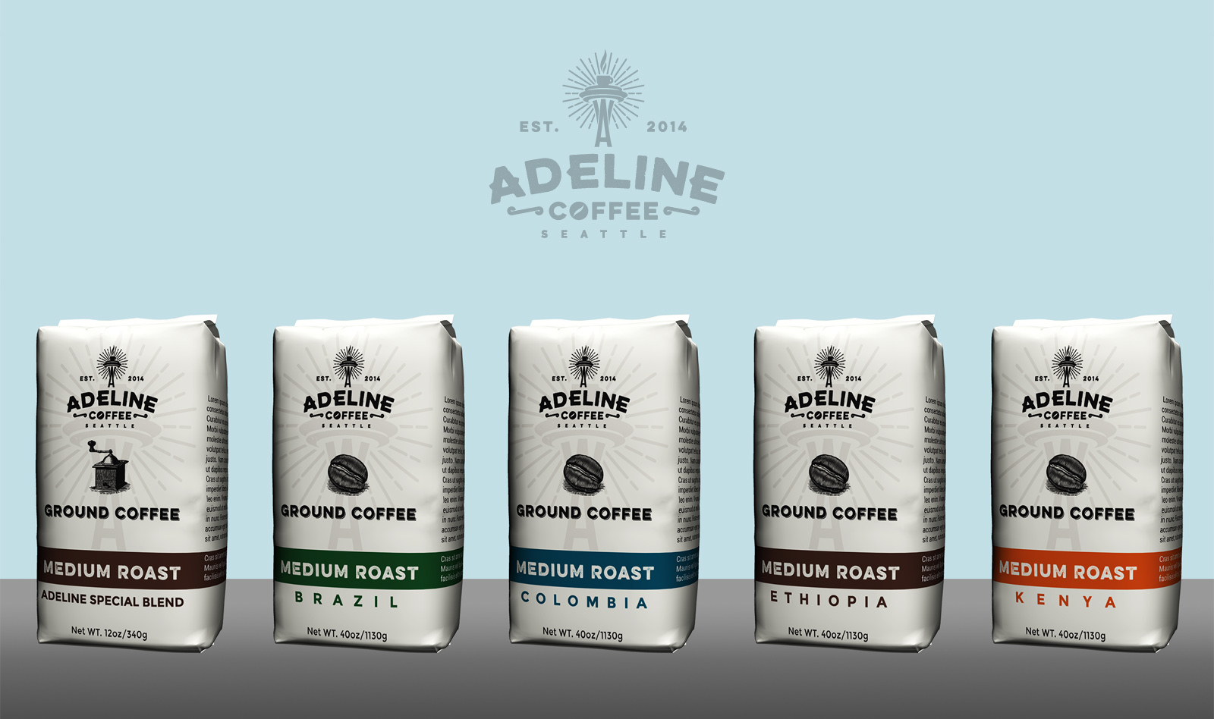

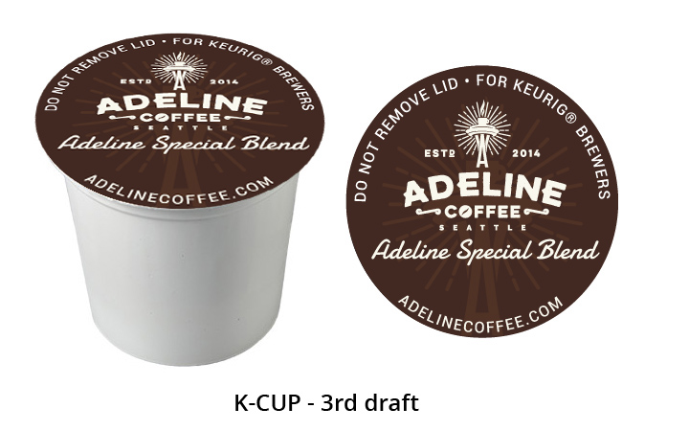

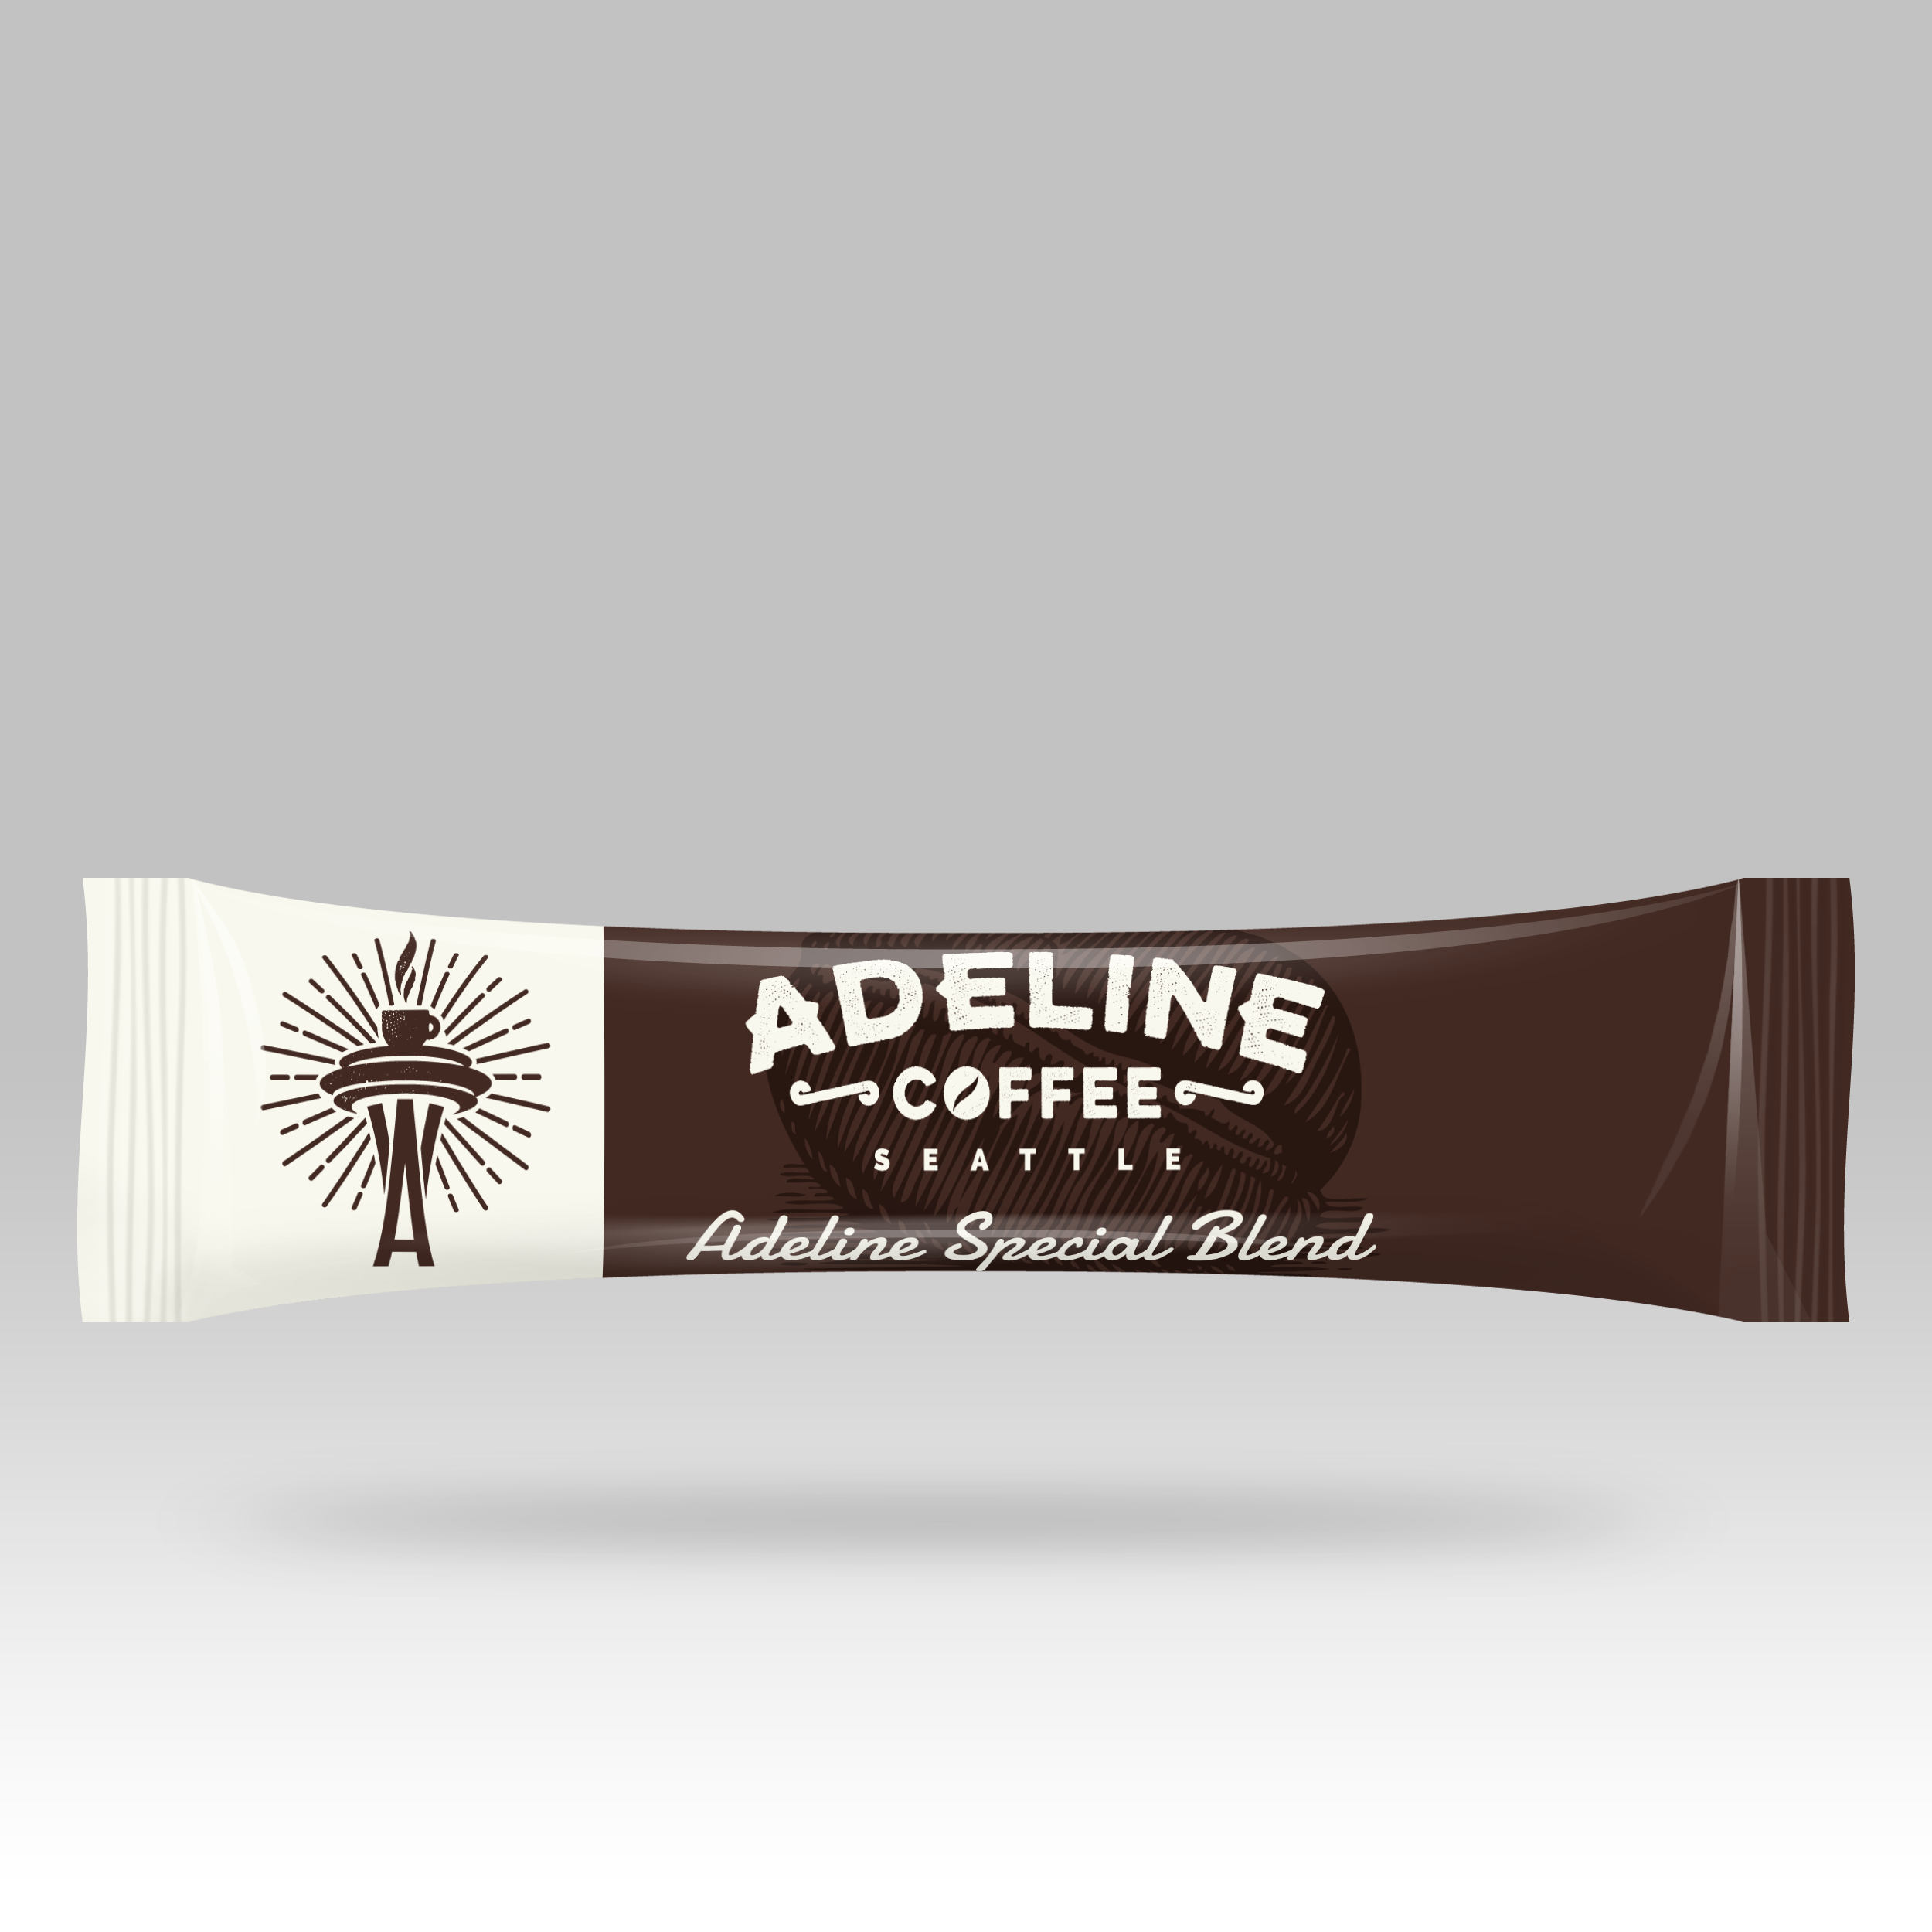 Hawaii, Vietnam, Yunnan, Laos, Indonesia, special mixed, k-cup, 3 in 1 coffee packet

**Hawaii**: Hawaiian coffee is grown primarily on the islands of Hawaii and Kauai, higher elevations and a relatively dry environment. The best estates grow beautiful, large, flat beans, which produce a medium-bodied brew, with buttery, spicy characteristics. Kona coffee offers a clean, mild, mellow coffee with just enough acidity to round off the cup.

**Vietnam**: Southeast Asia boasts some of the rarest coffees, largely untouched by Western culture, with sweet, nutty and vanilla tastes preserved in the natural beans. Vietnamese Coffee offers a new coffee discovery, full body flavors and an alternative coffee culture.

**Yunan**: A fine cup of Yunnan coffee displays a light to medium [body](http://www.espressocoffeeguide.com/all-about-coffee-2/coffee-flavor/body/) with a relatively mild [acidity](http://www.espressocoffeeguide.com/all-about-coffee-2/coffee-flavor/acidity/) and clean [taste](http://www.espressocoffeeguide.com/all-about-coffee-2/coffee-flavor/).

**Laos**: The Arabica beans produced in Laos are known for their medium body and a combination of mild citrus and floral tones.

**Indonesia**: They are known for their full-bodied, rich [taste](http://www.espressocoffeeguide.com/all-about-coffee-2/coffee-flavor/) and vibrant yet low-toned and gentle [acidity](http://www.espressocoffeeguide.com/all-about-coffee-2/coffee-flavor/acidity/), and long [finish](http://www.espressocoffeeguide.com/all-about-coffee-2/coffee-flavor/aftertaste/)/[aftertaste](http://www.espressocoffeeguide.com/all-about-coffee-2/coffee-flavor/aftertaste/). Indonesian coffees are quite earthy, full-bodied, clean, and thick.

**Kenya**: The darker roast brings out the rich, winey flavor of this premium coffee, so often rated better than all others by tasters. Particularly liked for its blackcurrant front palate and its flavorful, cleansing finish. Kenya coffee is rated within the industry as one of the world's best coffees, which offers an excellent balance of strong flavor, acidity and body. A coffee full of power and character.

**Ethiopian**: Ethiopian coffee from the Harar mountain district has distinctive chocolaty flavor and smooth short finish. It is among the worlds most unusual, offering a range of flavors from winey to fruity. Ethiopian Yirgacheffe is soft, with floral tones and is one of the best choices for iced coffee. Coffee from Ethiopia is a delight that shouldn't be missed.

**Brazil**: Brazilian coffees are among the world’s best coffees. Light, smooth and sweet, and they are also soft, nutty, low acid, with nice bittersweet chocolate tastes. It is also quite an exceptional base for making flavored coffees because of its softness in the cup.

**Colombia**: Colombia is famous for its consistently fine, mild coffees. Prized for its sweet aromatic taste, Colombian coffees are superbly balanced.

**Special blend**: Special Blends can deliver what very few stand alone coffees have: just the right acidity, the pleasing spice and fruit notes.

**K-cup**: Great coffee starts with great coffee beans. The single-serve cups are designed specially to ensure that you will experience the maximum flavor extraction from each cup you brew.

3 in 1 sticks: each single-serve packet has the right balance of ingredients, so you can get a creamy and sweet coffee drinking experience every time.

**Tea page: pictures with descriptions**

**All Dobashien teas are this year’s harvest, and they are also the first flush of this year. Dobashien harvests only the first flush, which is the best in terms of taste, aroma and water color.**

**Premium Sencha with Matcha (Fuji)**

Named after Mount Fuji, the highest mountain in Japan and a symbol of the country, Sencha Fuji is thick and sweet to taste. This luxurious sweetness is crafted by adding a small amount of premium matcha tea powder to Premium Sencha.

[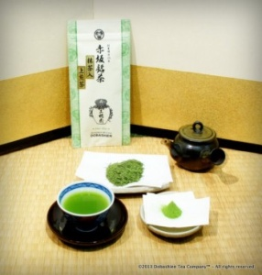](http://dobashientea.com/shop/sencha/141/premium-sencha-with-matcha-fuji/)

**Sencha (Ikkyu)**

As an introduction to the world of fine sencha tea, Sencha Ikkyu tea leaves have the ideal balance of savoriness (umami) and sweetness (amami) on one hand, and astringency and bitterness (shibumi) on the other.

[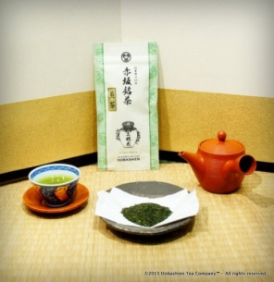](http://dobashientea.com/wp-content/uploads/2013/08/dobashien-sencha-ikkyu.jpg)

**Karigane (stem tea) with Matcha (Ran)**

Adding a small amount of premium Matcha tea powder to Karigane creates a noble, complex flavor that spreads through your tongue, and will make you fall in love all over again with Japanese tea.

[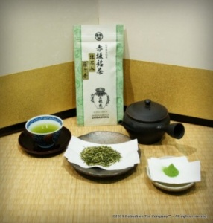](http://dobashientea.com/shop/stems/145/karigane-with-matcha-ran/)

**Karigane (stem tea) Sakura**

Lighter in color and containing more natural sugars than the leaves themselves, leaf stems create a natural, vegetal sweet tea.

[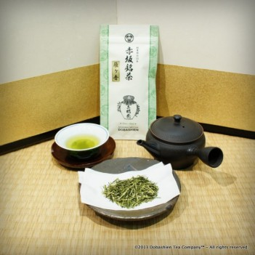](http://dobashientea.com/shop/stems/144/karigane-leaf-stems-sakura/)

**Premium Hojicha (Kizuna)**

The deep-roasted flavor of our Premium Hojicha “Kizuna” is drawn out of the rich taste of spring’ first flush

[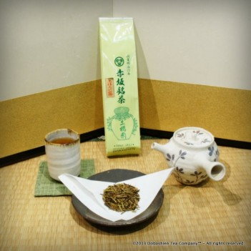](http://dobashientea.com/shop/hojicha/147/premium-hojicha-kizuna/)

**Hojicha(Wa)**

The second and third crop teas roasted at high temperature. It is important to brew plenty of tea leaves with high temperature boiling water to bring out the flavor. The elders and children can very much enjoy this tea, since there is a very small amount of caffeine and tannin content. You will find yourself refreshed drinking the tea after oily food.

[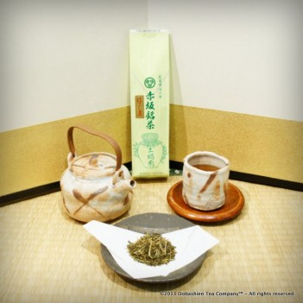](http://dobashientea.com/shop/hojicha/146/hojicha-roasted-green-tea-wa/)

**Genmaicha with Matcha (Nishiki)**

By adding our premium matcha tea powder to our genmaicha, we created a creamy and rich flavor.

[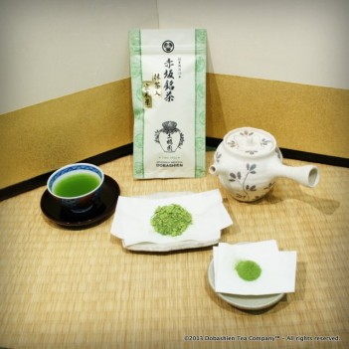](http://dobashientea.com/shop/genmaicha/149/genmaicha-with-matcha-nishiki/)

**Genmaicha(Niku)**

Genmaicha is a blend of sencha tea leaves and toasted rice that creates a deliciously nutty aroma. Some of the rice pops in the toasting, leading many to call this tea “popcorn tea”.

[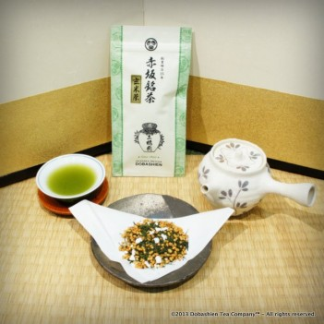](http://dobashientea.com/shop/genmaicha/148/genmaicha-kinu/)

**Treasure Box (Fuku) for gift**

Our Fuku Treasure Box is an assortment of Premium Sencha, Premium Sencha with Matcha, Karigane, Karigane with Matcha, Genmaicha and Genmaicha with Matcha. Enjoy 3 kinds of teas with and without Matcha tea powder.

[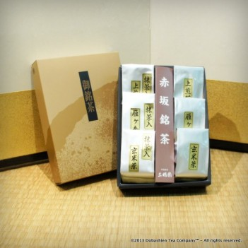](http://dobashientea.com/shop/treasure-boxes/150/dobashien-treasure-box-fuku/)

**Sencha (Best for ice tea)**

Asatsuyu is the best received traditional green tea at the World Tea Expo held in May for its mellow sweetness and refreshing aroma and beautiful clear green color. It can be brewed even with chilled water in minutes.

